Dr. M. G. R Government Arts and Science college for Women-Villupuram
Department of Physics
PAPER – 5
Subject Name: OPTICS Subject Code: BPH52
Syllabus

UNIT – I : GEOMETRICAL OPTICS
Spherical aberration in lenses – Methods of minimizing sphericl aberration – Condition for minimum spherical aberration in the case of two lenses separated by a distance – Chromatic aberration in lenses – Condition for achromtism of two thin lenses (in contact and out of contact)
– coma – astigmatism – Ramsden,s and Huygen’s eyepieces – Constant deviation spectrometer – Calculation of characteristic wave number of spectral lines.

UNIT – II : INTERFERENCE
Theory of thin films – Air wedge – Determination of diameter of a thin wire by air wedge – Michelson’s Interferometer – Theory – Applications – wave length, thickness of thin transparent material and resolution of spectral lines – Brewster’s fringes – Refractive index of gases – Jamin’s & Rayleigh’s Interferometers.

UNIT – III : DIFFRACTION
Fresnel,s diffraction – Diffraction at circular aperture, straight edge and single slit – Plane diffraction grating – theory and experiment to determine wavelength – normal incidence – oblique incidence – Fraunhofer,s diffraction – Missing orders – Overlapping spectra Rayleigh’s criteria – Resolving power of telescope, prism, microscope and grating.

UNIT – IV : POLARIZATION
Introduction to polarisation – Double refraction – Huygen’s explanation of double refraction in uniaxial crystal – Dichroism – Polaroids and their uses Plane, elliptically and circularly polarized light – Production and detection – Optical Activity – Fresnel’s explanation of optical activity – Specific Rotatory Power – Determination using Laurent’s Half Shade Polarimeter – Kerr effect and Faraday effect.

UNIT – V : FIBRE OPTICS
Introduction – Structure of an optical fibre - Classification of fibres based on Refractive index and number of modes of transmission – Theory of transmission of electromagnetic wave through fibres – Acceptance angle - Numerical aperture – absorbtion and scattering losses – optical fibre communication system - Application of optical fibres as wave guide and sensors.

Books for study:
1. Optics by Subramaniam N & Brij Lal, S Chand & Co. Pvt. Ltd., New Delhi, 1990.
2. Optics by Khnna D R & Gulati H R, R Chand & Co. Pvt. Ltd., New Delhi, 1979.
3. Optics and Spectroscopy by Murugeshn, S Chand & Co. Pvt. Ltd., New Delhi.
4. Optical fiber communications –Principles and Practice by John M Senior, Second edition, Prentice Hall, Pearson New Delhi.

5. Optical fiber communications by Gerd Keiser, Second edition, McGraw Hill

Books for Reference:
1. Fundamentals of Optics by Jenkins Francis and White E Harvey, McGraw Hill Inc., New Delhi, 1976.
2. Optical Physics by Lipson. S G, Lipson H and Tannhauser D S, Cambridge University Press (1995).
3. Fundamental of Optics by Raj M G, Anmol Publications Pvt. Ltd., (1996), New Delhi.
4. Fundamentals of Physics, 6th Edition, by D Halliday, R Resnick and J Walker. Wiley NY 2001.
5. Physics, 4th Edition Vols I, II & II Extended by D Halliday, R Resnick and K S Krane, Wiley, Ny, 1994.
6. CRC Handbook of Physics & Chemistry, 80th Ed., CRS Press, Ny, 1999.
7. The Feynman Lectures on Physics, Vols. I, II and III by R P Feynman, R B Leighton and M Sands, Narosa, New Delhi 1998.
8. Fibre Optic Communication System, Govind P. Agarwal, John –Willey & Sons.

UNIT- I
Geometrical Optics Introduction to lens systems:
A lens is made of glass and is bounded by two regular curved surfaces. Lens is an image forming device. It forms an image by refraction of light at its two bounding surfaces. A single lens with two refracting surfaces is a simple lens.
As it is easy to make spherical surfaces, most of the lenses are made of spherical surfaces and have a wide range of curvatures. Single lens are rarely used for image formation because they suffer from various defects. In optical instruments, such as microscopes, telescopes, camera etc. the combination of lenses are used for forming images of objects. An optical system consists of number of lenses placed apart, and having a common principal axis. The image formed by such a coaxial optical system is good and almost free of aberrations.

Cardinal points of lens systems:
In 1841 Gauss showed that any number of coaxial lenses can be treated as a single unit. The lens makers’ formula can be applied to measure the distances from two hypothetical parallel planes. The points of intersection of these planes with the axis are called the principal points or Gauss points.
There are six points: (i) Two focal points, (ii) Two principal points and (iii) Two nodal points. These six points are known as Cardinal points of an optical system. The planes passing through these points and which are perpendicular to the principal axis are known as cardinal planes. We can find the image of any object without making a detailed study of the passage of the rays through the system using cardinal points.
- Principal points and Principal planes:
- 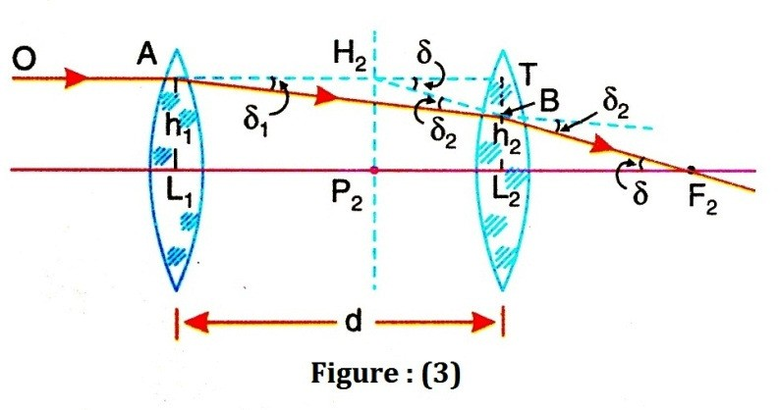Consider an optical system having its principal focal points F₁ and F₂. A ray OA travelng parallel to the principal axis and incident at A is brought to focus at F₂ in the image space as shown in the given figure
(3).
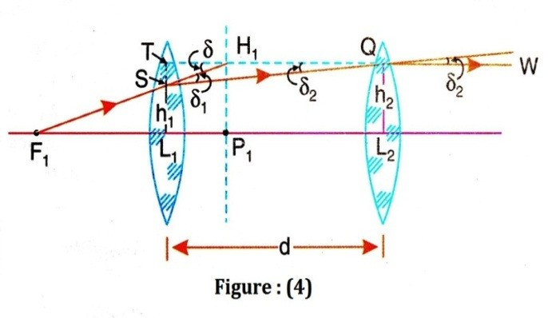The actual ray is refracted at each surface of the optical system and follows the path OABF₂. If we extend the incident ray OA forward and the emergent ray BF₂ backward, they meet each other at H₂. A plane drawn through the point H₂ and perpendicular to the principal axis. This plane is called the principal plane of the optical system.
H₂P₂ is the principal plane in the image space and is called the second principal plane. The point P₂ at which the second principal plane intersects the axis, is called the second principal point.
- Now consider figure (4), we can locate the principal plane H₁P₁ and
principal point P₁ in the object space. Consider the ray F₁S passing through the first principal focus F₁ such that after refraction it emerges along QW parallel

to the axis (as in figure (3). The rays F₁S and QW intersect at H₁. A plane perpendicular to the axis and passing through H₁ is called the first principal plane. The point of intersection P₁ of the first principal plane with the axis is called the first principal point.

- 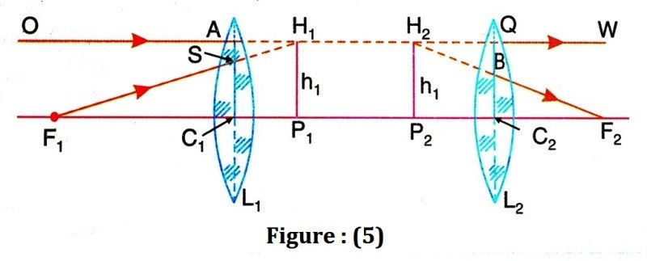Conjugate planes: Consider figure (5) the two incident rays (F₁S & OA) are directed towards H₁ and after refraction seem to come from H₂. Therefore, H₂ is the image of H₁. Thus H₁ and H₂ are the conjugate points and the planes H₁P₁ and H₂P₂ are pair of conjugate planes. It has also been observed that H₂P₂ = H₁P₁.
Thus lateral magnification of the planes is +1. Thus, the first and second principal planes are planes of unit magnification and are therefore called as unit planes and points P₁ and P₂ are called unit points. Note that principal planes are conceptual planes and do not have physical existence within the optical system.

- Focal Points and Focal Planes:
When a parallel beam of light traveling from the left to the right (in object space) is incident on the optical system then the beam comes together at a point F₂, on the other side (in image space) of the optical system. The beam passes through the point F₂ is called the second focal point of the optical system.
A beam of light passing the point F₁ on the axis of the object side is travel parallel to the axis after emergence through the optical system as shown in figure (5). This point F₁ is called the first focal point.
Thus the focal points can be defined as
- The first focal point: The first focal point is a point on the principal axis of optical system such that a beam of light passing through it is travel parallel to the principal axis after refraction through the optical system.
- The second focal point: The second focal point is a point on the principal axis of the optical system such that a beam of light traveling parallel to the principal axis of the optical system passes through it after refraction through the system.
The planes passing through the principal focal points F₁ &F₂ and perpendicular to the axis are called first focal plane and second focal plane respectively.

Properties of focal planes:
- The main property of the focal planes is that the rays starting from a point in the focal plane in the object space corresponds to a set of conjugate parallel rays in the image space. Similarly, a set of parallel rays in the object space corresponds to a set of rays intersecting at a point in the focal plane in the image space.
- The distance of the first focal point from the first principal point, i.e. F₁P₁ is called the first focal length f₁ of the optical system and the distance of the second focal point from the second principal point F₂P₂ is called the

second focal length f₂. f₁ and f₂ are also known as the focal lengths in the object space and image space respectively.
- When the medium is same on the two sides of the optical system f₁=f₂

- Nodal Points and Nodal Planes:
Nodal points are the points on the principal axis of the optical system where light rays, without refraction, intersect the optic axis. The planes passing through the nodal points and perpendicular to the principal axis are called the nodal planes. Where as the principal planes are the planes where all refractions are assumed to occur and the nodal planes are planes where refraction does not take place. Figure (6) represents an optical system with the help of its cardinal points.
A ray of light AN₁ directed towards one of the nodal points N₁, after
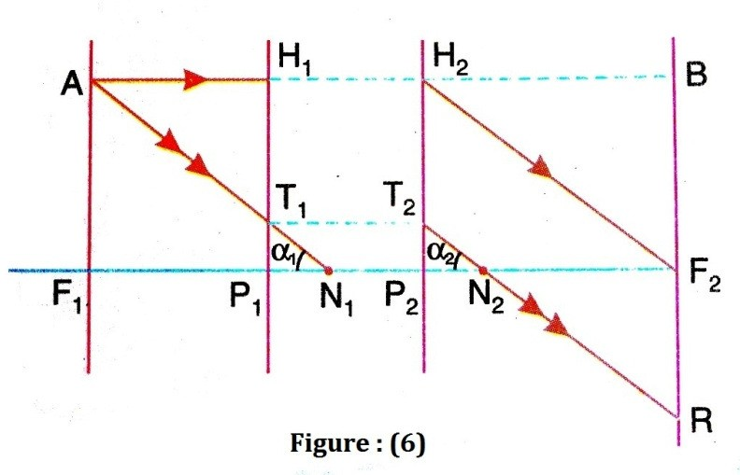
refraction through the optical system along N₁N₂, the ray emerges out from the second nodal point N₂ in a direction N₂R parallel to the incident ray. The distances of the nodal points are measured from the focal points.

Properties of nodal points and nodal planes:

- The nodal points are a pair of conjugate points on the axis having unit positive angular magnification
Let H₁P₁ and H₂P₂ be the first and second principal planes of an optical system. Let AF₁ and BF₂ be the first and second focal plane respectively. Consider a point a situated on the first focal plane. From A draw a ray AH₁ parallel to the axis. The conjugate ray will proceed from H₂, appoint in the second principal plane such that H₂P₂ = H₁P₁ and will pass through the second focus.
Take another ray AT₁ parallel to the emergent ray H₂F₂ and incident on the first principal plane at T₁. It will emerge out from T₂, a point on the second principal plane such that T₂P₂ = T₁P₁, and will proceed parallel to the ray H₂F₂. The point of intersection of the incident ray AT₁ and the conjugate emergent ray T₂R with the axis give the positions of the nodal points. It is clear that two points N₁ and N₂ are a pair of conjugate points and the incident ray AN₁ is parallel to the conjugate emergent ray T₂R.
Further, tan α₁ = tan α₂

The ratio tan α2 = y represents the angular magnification.
tan α1
∴ tan α2 = 1 (12)
tan α₁
Therefore, the points N₁ and N₂ are a pair of conjugate points on the axis having unit positive angular magnification.

- The distance between two nodal points is always equal to the distance between two principal points
In figure (6), we see that in the right angled ∆^{Sec} T₁P₁N₁ and T₂P₂N₂
T₁P₁ = T₂P₂
∠T₁P₁N₁ = ∠T₂P₂N₂ = α
Therefore, the two ∆^{Sec} are congruent.
∴ P₁N₁ = P₂N₂
Adding N₁P₂ to both the sides, we get
∴ P₁N₁ + N₁P₂ = P₂N₂ + N₁P₂
∴ P₁P₂ = N₁N₂ (13)
Thus, the distance between the principal points N₁ and N₂ is equal to the distance between the principal points P₁ and P₂.

- The nodal points N₁ and N₂ coincide with the principal points P₁ and P₂ respectively whenever the refractive indices on either side of the lens are the same.
Now consider the two right angled ∆^{Sec} T₁P₁N₁ and T₂P₂N₂ in figure (6).
AF₁ = H₂P₂
∠AN₁F₁ = ∠H₂F₂P₂
∴ The two ∆^{Sec} are congruent.
F₁N₁ = P₂F₂
But F₁N₁ = F₁P₁ + P₁N₁
∴ F₁P₁ + P₁N₁ = P₂F₂
∴ P₁N₁ = P₂F₂ − F₁P₁
Also
P₂F₂ = +ƒ₂ and P₁F₁ = −ƒ₁
∴ P₁N₁ = P₂N₂ = (ƒ₁ + ƒ₂)
As the medium is the same, say air, on both the side of the system
ƒ₂ = −ƒ₁
∴ P₁N₁ = P₂N₂ = 0 (14)
Thus, the principal points coincide with the nodal points when the optical system is situated in the same medium.

Construction of image using cardinal points:
The cardinal points are used to construct the image corresponding to any object placed on the principal axis of the system.
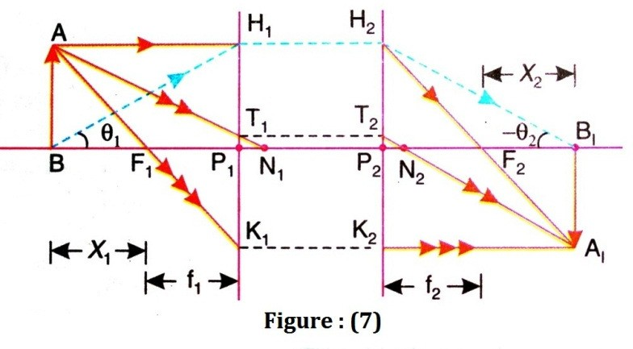

Suppose F₁, F₂ be the principal foci, P₁,P₂ the principal points and N₁,N₂ the nodal points of the optical system as shown in the given figure (7). AB is a linear object on the axis. Now in order to find the image of the point A we make the following construction.

- A ray AH₁, is drawn parallel to the axis touching the first principal plane at H₁. The conjugate ray will proceed from H₂ a point on the second principal plane such that H₂P₂ = H₁P₁ and will pass through the second principal focus F₂.
- A second ray AF₁K₁ is drawn passing through the first principal focus F₁ and touching the first principal plane at K₁. Its conjugate ray will proceed from K₂ such that K₂P₂ = K₁P₁ and it will be parallel to the axis.
- A third ray A₁T₁N₁ is drawn which is directed towards the first nodal point N₁. This ray passes after refraction through N₂ in a direction parallel to AN_{1.}
The point of interaction of any of the above two refracted rays will give the image of
A. Let it be A₁. The perpendicular is drawn from A₁ on to the axis gives the image A₁B₁ of the object AB.

Newton’s formula:
Consider the given figure (7), it is seen that ∆^{Sec} ABF₁ and F₁K₁P₁ are similar
K₁P₁ = P₁F₁

But K₁P₁ = A₁B₁
AB

∴ A₁B₁ = ƒ₁

BF₁

(15)

AB x₁
Further , ∆^{Sec} A₁B₁F₁ and H₂P₂F₂ are similar
A₁B₁ = B₁F₂

But H₂P₂ = AB
H₂P₂
A₁B₁ = x₂

P₂F₂

(16)

AB ƒ₂
From equation (15) and (16) we get

∴ ℎ₂ = ƒ₁ = x₂

(17)

ℎ₁ x₁ ƒ₂
or x₁x₂ = ƒ₁ƒ₂ (18)
This is the Newton’s formula.

Combination of two thin lenses
The cardinal points of a coaxial optical system is determined by assuming first
that the object at infinity.

- When object at infinity: Here we consider an object located at infinity, see given figure.
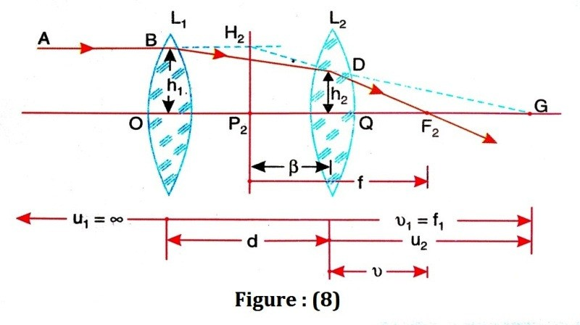

AB is a ray of light coming from an object situated at a very large distance, such that u₁ = ∞ . The lens L₁ forms an image at G. However, because of the presence of the second lens L₂. G becomes the virtual object for L₂. The ray BD, instead of going along BDG, refracts along the path DF₂. When the ray AB is produced forward and the ray DF₂ backward, they intersect at H₂. The plane H₂P₂ normal to the axis may considered as the plane at which the refraction occurred and the plane is called principal plane.

- Focal length of the system:
Now we can write the expression for the refraction taking place at the surface of first lens as follows:

1 − 1 = 1
∴ 1 − 1 = 1

v1 u1 f1
OG u1 f1

As u₁ = ∞ , we obtain OG =f₁
The equation for the refraction at the second lens may be written as

1 1 1
∴ − =
∴ 1 − 1 = 1

v u2 f2
QF2 QG f2

or ∴
1 =
QF2
1 + 1
f 2 f1 − d
∴ 1 =
QF2
f1 + f2 − d f₂ ( f₁ − d )
(19)

The ∆^{Sec} BOG and DQG are similar and also the ∆^{Sec} H₂P₂F₂ and DQF₂ are

similar
∴ BO = DQ
∴ h1 = h2
(20)

OG QG f1 ( f1 − d )

∴ H 2 P2
= DQ
∴ h1 = h2
(21)

P2 F2
QF2
f QF2

From equation (19), (20) and (21) we get

h1 =
h2
or
f1 =
( f1 − d )
f ( f1 + f2 − d )

f2 ( f1 − d )

1 = f1 + f2 − d f f1 f2
(22)

∴ 1 = 1 + 1 − d

f f1 f2 f1 f2
(23)

The location of focal point F₂ is determined by QF₂, which is known from the equation, the position of the principal plane P₂ is specified by the value of f calculated from equation (23).

- Cardinal points
(i) Second principal point :
Let us say the second principal plane H₂P₂ is located at a distance of L₂P₂ = þ from the second lens L₂. According to sign convention β would be negative as it is measured toward the left of lens.
∴ QF₂ = ƒ − (−þ) = ƒ + þ
We can determine þ using the equation for f into the above relation. Thus,

ƒ + þ = ƒ₂(ƒ₁ − d)
ƒ₁ + ƒ₂ − d

þ = −ƒ + ƒ₂(ƒ₁ − d) = −ƒ₁ƒ₂ + ƒ₂ƒ₁ − ƒ₂d

ƒ₁ + ƒ₂ − d ∆ ∆

Where ∆= ƒ₁ + ƒ₂ − d
∴ þ = −ƒ d

(24)

2 ∆
or
þ = − ƒ2d
ƒ₁ + ƒ₂ − d

(25)

But from eq. (22), we have ƒ₁ + ƒ₂ − d = ^{ƒ1ƒ2}
ƒ
þ = − ƒd
ƒ₁

(26)

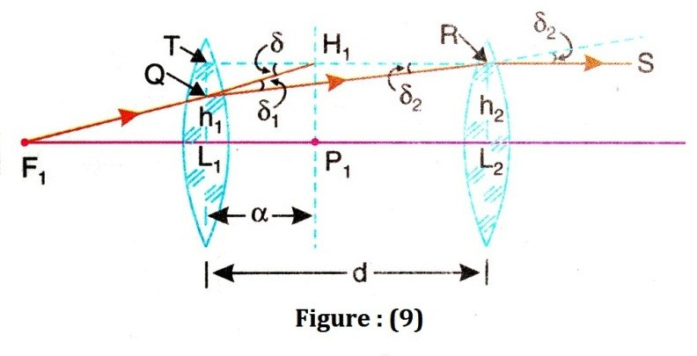

(ii) First principal point :
By considering a ray of light parallel to the axis and incident on the second lens L₂ from the right side, we can show that the distance of first principal plane. L₁P₁ = α from the first lens L₁ is given by

α = ƒ d

(27)

Also,
1 ∆

α = + ƒd
ƒ₂

(28)

This is the same as the result.

  - Second focal point :
Referring to figure (8), the distance of the second focal point F₂ from the second lens L₂ is given by
L₂F₂ = P₂F₂ − P₂L₂

= ƒ − (−L₂P₂) = ƒ + þ
= ƒ + (− ƒd)
ƒ₁

  - First focal point :
d
∴ L₂F₂ = ƒ (1 − ƒ1) (29)

The distance of the first focal point F₁ from the first lens L₁is given by

L₁F₁ = P₁F₁ − P₁L₁

= −ƒ − (−L₁P₁) = −ƒ + α
ƒd
= −ƒ + ( ƒ2 )
d
∴ L₁F₁ = −ƒ (1 − ƒ2) (30)
  - and (vi) nodal points :
As the optical system is considered to be located in air, P₁ and P₂ are also the positions of nodal points N₁ and N₂ respectively.

Lens Aberrations
The imperfect quality of the image formed by lens is known as lens
aberration or the deviation of real images from the ideal images, in respect of the actual size, shape and position are called aberrations. In actual practice the objects are bigger and a lens is required to produce a bright and magnified image.
The wide angle rays from the centre of the object and also the upper and lower parts of the object and falling near the top and bottom of the lens. These rays are known as peripheral or marginal rays.
In general, (a) peripheral rays of light do not meet at a single point after refraction through the lens. (b) the refractive index and hence the focal length of a lens is different for different wave lengths of the light.
For a given lens, the refractive index for violet light is more than that for red
light.
There are two types of aberrations:
- Monochromatic aberration: The defects due to wide-angle incidence and peripheral incidence or aberration for monochromatic light, are called monochromatic aberrations.
- Chromatic aberration: The aberrations occur due to dispersion of light are called chromatic aberrations.
Types of monochromatic aberration:
Monochromatic aberrations are again divided in to five types and they are
- Spherical aberrations
- Coma
- Astigmatism
- Curvature of field
- Distortion
Spherical aberration
Definition: The peripheral rays passing through a lens are refracted more and
come to focus closer to the lens. Paraxial rays passing through the lens are refracted less and come to focus away from the lens. Therefore, rays passing through different zones of a lens surface come to focus at different points. An image formed by paraxial rays will be surrounded by the image of peripheral rays and the image is blurred. This phenomenon is known as Spherical aberration.

Theory: The spherical aberration in the image formed by a single lens is shown in figure (10). Here O is a point object on the axis of the lens and I_{p} and I_{m} are the images formed by the paraxial and marginal rays respectively. In figure it is very clearly that paraxial rays of light from the image at a longer distance from the lens than the marginal rays.
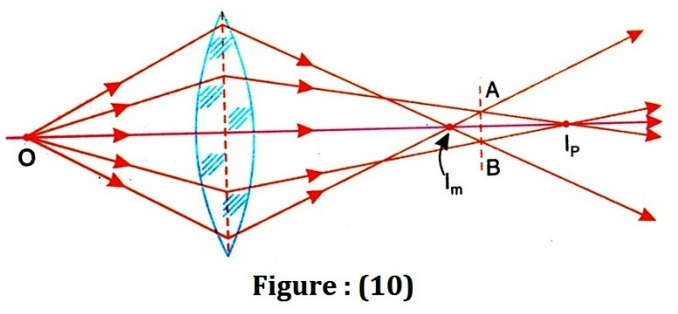

The image is not sharp at any point on the axis. If the screen is placed perpendicular to the axis at AB, the image appears to be a circular patch of diameter AB. At positions on the two sides of AB, the image patch has a large diameter. The patch of diameter AB is called the circle of least con fusion, which corresponds to the position of the best image.
The distance I_{m} I_{p} measures the longitudinal spherical aberration. The radius of the circle of least confusion measures the lateral spherical aberration.
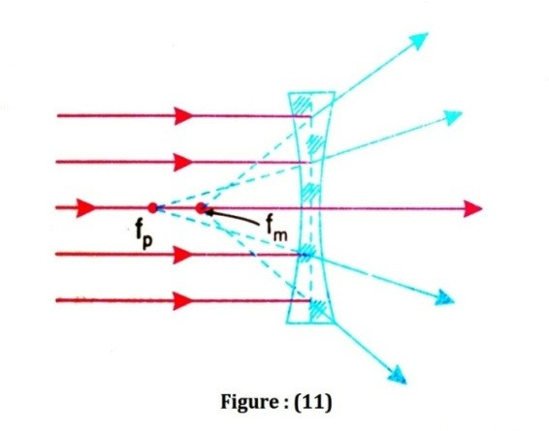Thus, for an object point O on the axis, the image extends over the length I_{m} I_{p.} This effect is called spherical aberration.
Figure (11) shows the spherical aberration produced by a concave lens.
The spherical aberration produced by a lens depends on the distance of the object point and varies approximately as the square of the distance of the object ray above the axis of the lens. The spherical aberration produced by a convex lens is positive and that produced by a concave lens is negative.

- Methods for reducing spherical aberration:
- Spherical aberration can be minimized by using stops, which reduces the effective lens aperture. The stop used can be such as to permit either the axial rays of light or the marginal rays of light. However, as the amount of light passing through the lens is reduced, correspondingly the image appears less bright.

- The conditions for minimum spherical aberration is
dx = 0
dk
where x is the longitudinal spherical aberration and,
k = R1
R2

(31)

Where, R1 and R2 are the radii of curvature. Now, differentiation of equation of spherical aberration gives

k = R1
R2
= μ (2μ −1) − 4
μ (2μ +1)
(32)

For a lens of refractive index μ=1.5 we get k= - 1/6. Thus, the lens, which produces minimum spherical aberration, is biconcave and the radius of curvature of the surface facing the incident light is one-sixth the radius of curvature of the other face. In general, the more curved surface of the lens should face the incident beam of

light. Lens whose (12).
R1 = − 1
R2 6
is called a cross lens. A crossed lens is shown in figure

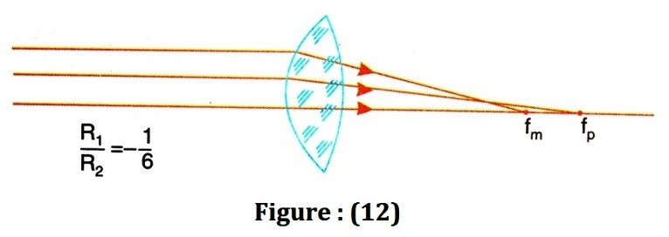

- 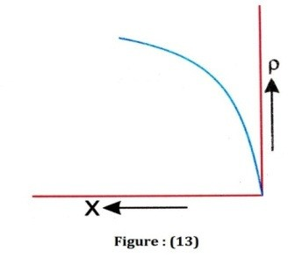Plano-convex lenses are used in optical instruments so as to reduce the spherical aberration. When the curved surface of the lens faces the incident light, the spherical aberration is minimum. The spherical aberration in crossed

lens
R1 = − 1 is only 8% less than that of a plano-
R2 6

convex lens having the same focal length and
radius of the lens aperture. This is the reason why plano-convex lenses are generally used in place of crossed lenses without increasing the spherical aberration appreciably. Figure (13) represents the variation of longitudinal spherical aberration with the radius of the lens aperture for lenses of the same focal length and refractive index.
The spherical aberration will be very large if the plane surface faces the incident light. The spherical aberration is a result of larger deviation of the marginal rays than the paraxial rays. If the deviation of the marginal rays of light is made minimum, the focus f_{m} for a parallel incident beam will shift towards f_{p} , the focus for the paraxial rays of light and the spherical aberration will be minimum.
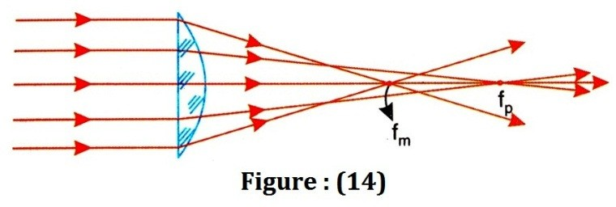

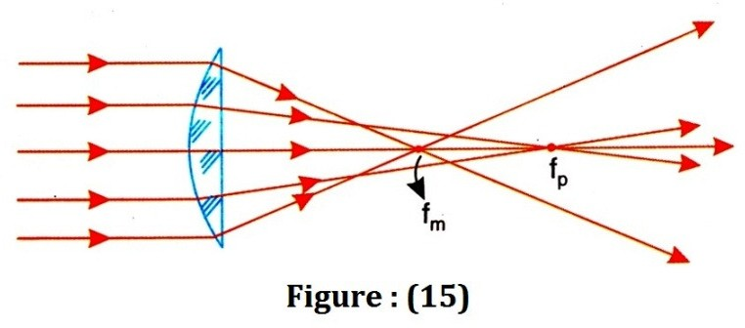

In plano-convex lens, when the plane surface faces the parallel beam of light , the deviation is produced only at the curved surface and hence the longitudinal spherical aberration (figure (14)) is more than when the curved surface faces the incident light, as shown in figure (15).
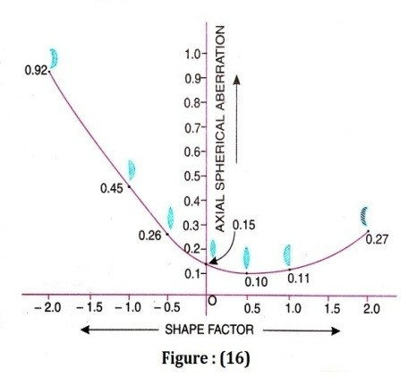The spherical aberration produced by a by a single lens can be minimized by choosing proper radii of curvature.The shape factor q of the lens is given by q = R1 + R2
R2 − R1
The spherical aberration for a double convex lens (shape factor q=0.5) is a minimum when the surface of smaller radius of curvature faces the incident parallel light. The spherical aberration for a plano-convex lens (shape factor q=+1.0) when the
curved surface faces the incident light is only slightly more than the double convex lens. Hence, plano-convex lenses are preferred.

- Spherical aberration can also be made minimum by using two plano-convex lenses separated by a distance equal to the difference in their focal length. In this arrangement, the two lenses equally share the total deviation and the spherical aberration is minimum. In figure (17), two plano-convex lenses of focal length f₁ and f₂ are separated by a distance d.
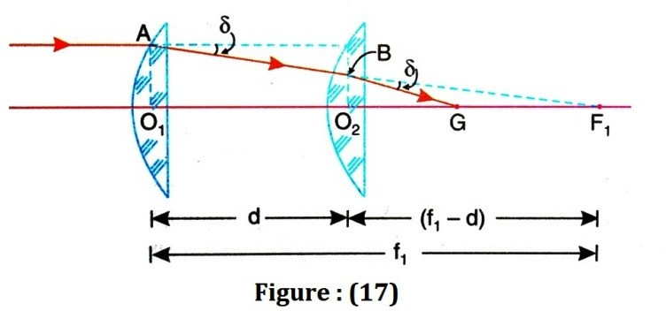

Let δ be the angle of deviation produced by each lens see figure (17).
∠BF₁G = δ , ∠F₁BG = δ
And from triangle BGF₁, BG= GF₁ or O₂G = GF₁ (approximately)
O G = 1 (O F ) = 1 (ƒ − d)
2 2 2 1 2 1
For the second lens F₁ is the virtual object and G is the real image. Substituting these values of object and image distances in formula

1 − 1 = 1
v u f2
1 − 1 = 1
O2G O2 f1 f2
2 − 1 = 1
( f1 − d ) ( f1 − d ) f2
1 = 1 ( f1 − d ) f2

f2 = f1 − d or d = f1 − f2
(33)

- Thus, the condition for minimum spherical aberration is that the distance between the two lenses is equal to the difference in their focal lengths

- Spherical aberration for a convex lens is positive and that for a concave lens is negative. By a suitable combination of convex and concave lenses spherical aberration can be made minimum.

- Spherical aberration may be minimized by using axial –GRIN lenses.

Coma
Definition: When object point is not situated on the axis then aberration
produced by the lens is called Coma.
Theory: In the case of Spherical aberration, the image is a circle of varying diameter along the axis and in the case of Comatic aberration the image is comet shaped and hence the name is coma.
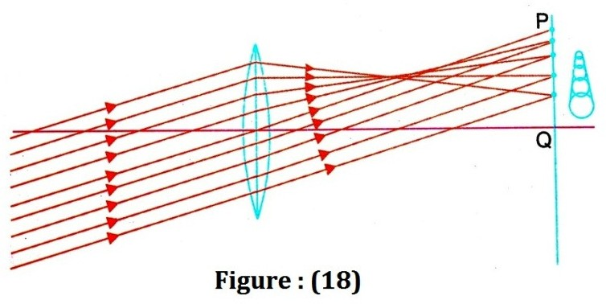

The effect of coma when the resultant image of a point off the axis is shown on the right side of the figure (18). The rays of light in the tangential plane are represented in the figure.
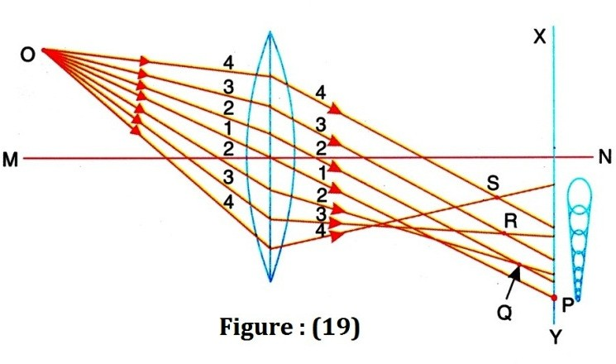

The presence of coma in the image due to a point object O situated off the axis of the lens is shown in above figure (19).The rays of light getting refracted through the centre of the lens(ray 1) meet the screen XY at the point P. rays 2.2, 3.3, etc getting refracted through the outer zones of the lens come to focus at points Q,R,S, etc. , nearer the lens and overlapping circular patches of gradually increasing diameter are formed on the screen. The resultant image of the point is comet- shaped as shown on the right side of the figure.
Let 1, 2, 3 etc., be the various zones of the lens See the figure (20a). Rays of light getting refracted through these different zones give rise to circular patches of light 1’,2’,3’, etc. The screen is placed perpendicular to the axis of the lens and at the position where the central rays come to focus as in Figure (20b).
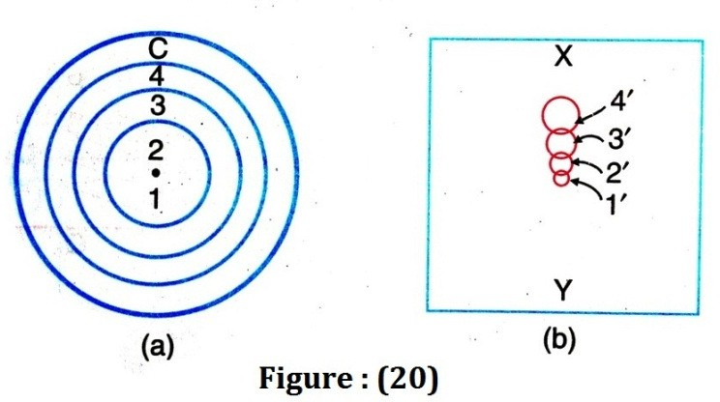
Coma is the result of varying magnification for rays refracted through different zones of the lens. In figure (19), rays of light getting refracted through the outer zones come to focus at points nearer the lens. Hence the magnification of the image due to the outer zones is larger than the inner zones and in this case coma is said to be positive. If the magnification produced in an image due to the other zones is similar, coma is said to be negative.

Methods of reduction:
- The coma can be corrected by properly choosing the radii of curvature of the lens surface. A lens corrected for coma will not be free from spherical aberration and the one corrected for spherical aberration will not be free from coma.
- Use of a stop or a diaphragm at the proper position eliminates coma.
- According to abbe, a German optician, coma can be eliminated if a lens satisfies the Abbe’s sine condition viz.
μ₁ y₁ sinθ₁ = μ₂ y₂ sinθ₂ (34)
Where μ₁, y₁ & θ₁ refer to the refractive index, height of the object above the axis, and the stop angle of the incident ray of light respectively. Similarly μ₂, y₂ & θ₂ refer to the corresponding quantities in the image space. The magnification of the image is

given by y2
y1

y2 =
y1

μ1 sin θ1

μ2 sin θ2

(35)

Elimination of coma is possible if the lateral magnification y2
y1
is the same for all

rays of light. Thus coma can be eliminated if,

constant.
sin θ1

sin θ2
is a constant because
μ1 is
μ2

- A lens that satisfies the above condition is called an aplanatic lens.

Astigmatism
Definition: Astigmatism is the aberration in the image formed by a lens when
the object points is off the axis. The difference between Astigmatism and coma is that in coma the spreading of the image takes place in a plane perpendicular to the lens axis and in Astigmatism the spreading takes place along the lens axis.

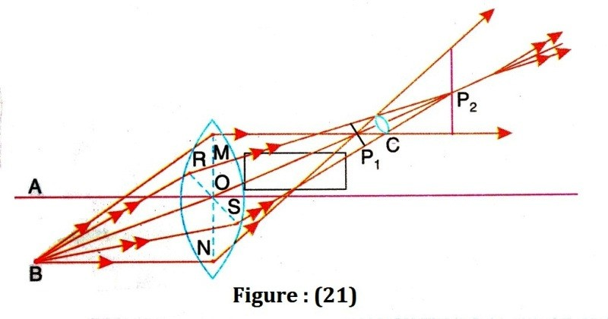Theory:

Figure (21), illustrates the defect of Astigmatism in the image of a point B situated off the axis. The cone of the rays of light refracted through the tangential (vertical) plane BMN comes to focus at point P₁ nearer the lens and the cone of rays refracted through the sagitial (horizontal) plane BRS comes to focus at the point P₂ away from the lens. All rays pass through a horizontal line passing through P₁ called primary image and through a vertical line passing through P₂ called secondary image. The refracted beam has an elliptical cross-section, which ends to a horizontal line at P₁ and a vertical line at P_{2.}the cross section of the refracted beam is circular at some point between the primary and secondary images and this is called the circle of least confusion. If a screen is held perpendicular to the refracted beam between the points P₁ and P₂ the shape of the image at different positions is as shown in the figure (22) here.
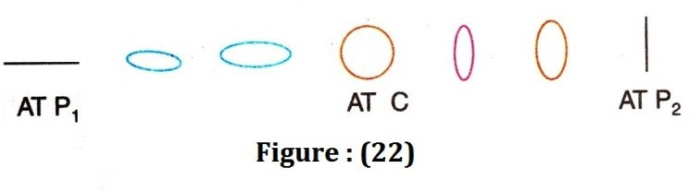

The primary and the secondary image surfaces and the surface of the best focus are illustrated in the figure (23).
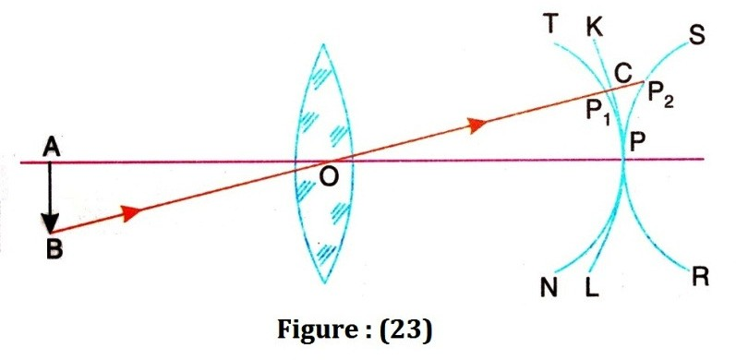

P₁ and P₂ are the images of object point B . TPN and SPR are the first and the second image surfaces and KPL is the surface of the best focus. The three surfaces touch at the point P on the axis. Generally the surface of the best focus is not plane but curved as shown. This defect is called the curvature of the field. The shape of the image surfaces depends on the shape of the lens and the position of the stops.
If the primary image surface is to the left of the secondary image surface then it is called positive astigmatism, and if the primary image surface is to the right of the secondary image surface then it is called negative astigmatism.

Method of reduction:
By using a convex and a concave lens of suitable focal length and separated by a distance, it is possible to minimize the astigmatic difference and such a lens combination is called an anastigmat.
Curvature of the field
Definition: The image of an extended object due to a single lens is not a flat
one but it will be a curved surface. The central portion of the image nearer the axis is in focus but the outer regions of the image away from the axis are blurred. The paraxial focal length is greater than the marginal focal length. This defect is called the curvature of the field.
This aberration is present even if the aperture of the lens is reduced by a suitable stop. The figure illustrates the presence of curvature of the field in the image formed by a convex lens. A real image formed by a convex lens curves towards the lens ( fig.24) and a virtual image curves away from the lens (fig.25)
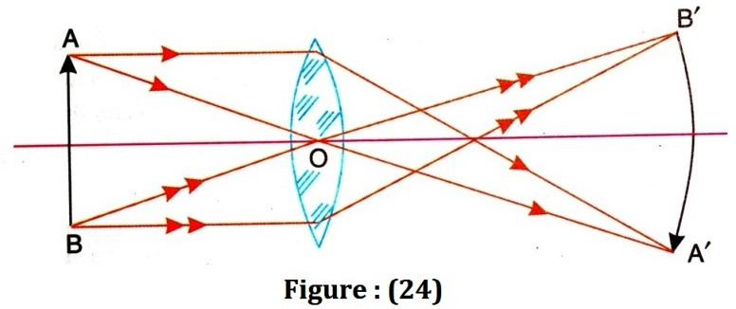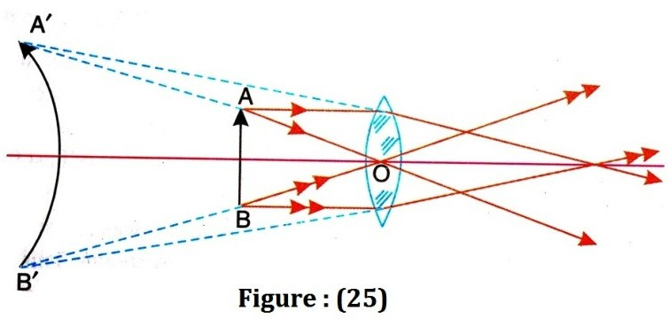

Figure (26) represents the curvature of the field present in the image formed by a curvature of the field present in the image formed by a concave lens.

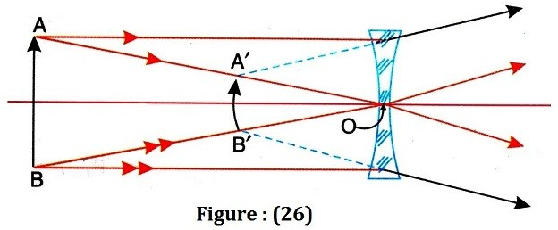

For a system of thin lenses, the curvature of the final image can, theoretically, be given by the expression

1 = ∑
R
1

μn fn
(36)

Where R is the radius of the final image, μ_{n} and f_{n} are the refractive index and focal length of the n^{th} lens. For the image to be flat, R must be infinity

∴ 1 = ∑
R
1
μn fn
= 1 = 0
∞

Correspondingly, the condition for two lenses placed in air, reduces to

1

μ1 f1
+ 1 = 0
μ2 f2
(37)

This is known as Petzwal’s condition for no curvature. This condition holds good whether the lenses are separated by a distance or placed in contact. As the refractive indices μ₁ and μ₂ are positive, the above condition will be satisfied if the lenses are of opposite sign. If one of the lenses is convex the other must be concave.
Distortion
Definition: The variation in the magnification produced by a lens for different
axial distances produce an aberration is called distortion.
There are two types of distortion:
(1) pi-cushion distortion and (2) barrel-shaped distortion.
In pi-cushion distortion, the magnification increases with increasing axial distance and the image of an object is shown in figure (29 b).
In barrel-shaped distortion, the magnification decreases with increasing the axial distance and the image of an object is shown in figure (23 c).
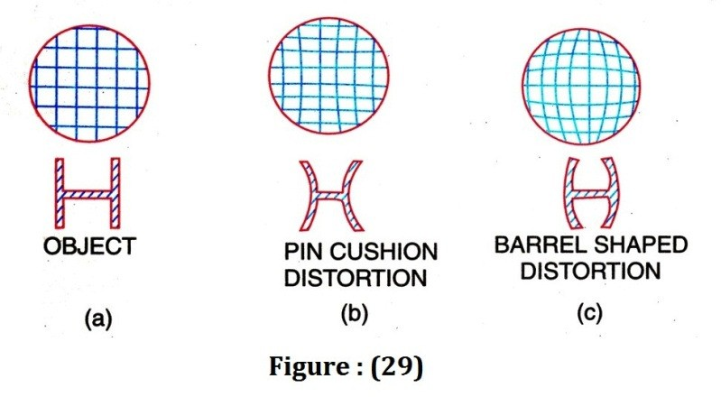
In the case optical instruments, a little amount of distortion may be present but it must be completely eliminated in a photographic camera lens, where the magnification of the various regions of the object must be the same.

In the absence of stops, which limit the cone of rays or light striking the lens, a single lens is free from distortion. But, if stops are used, the resulting image is distorted.
If a stop is placed before the lens the distortion is barrel-shaped see figure
- and if stop is placed after the lens, the distortion is pin-cushion type see figure (31).
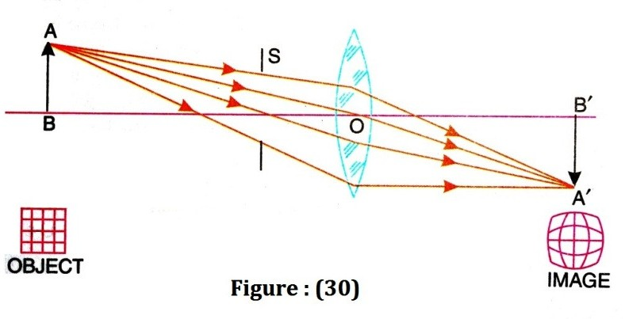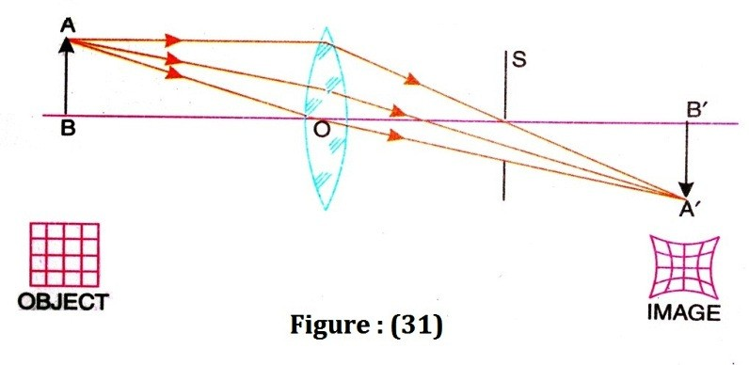
To eliminate distortion a stop is placed between two symmetrical lenses, so that the pin-cushion distortion produced by the first lens is compensated by the barrel-shaped distortion produced by the second lens see figure (32). Projection and camera lenses are constructed in this way.
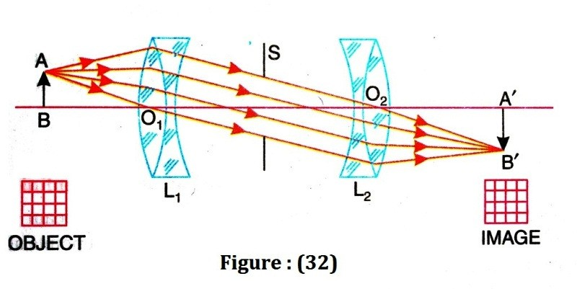
Chromatic aberration in a lens
Definition: A single lens produces a coloured image of object illuminated by
white light and this defect is called chromatic aberration. Elimination of this defect in a system of lenses is called achromatism.
  - Expression for longitudinal chromatic aberration for an object at infinity.
When a parallel beam of white light is passed through a lens, the beam gets dispersed and rays of light of different colours come to focus at different points along the axis. The violet rays of light come to focus at a point nearer the lens and the red rays of light at a farther point see figure (33). f_{v} is the focus for the violet rays and f_{r} is the focus for the red rays. The colours in between violet and red come to focus between f_{v} and f_{r}. The distance (f_{r} - f_{v}) =x is called the longitudinal or axial chromatic aberration.

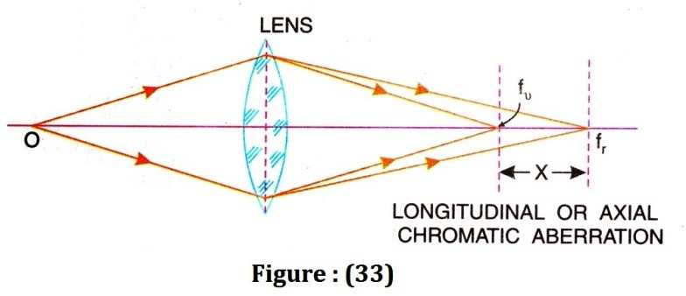

The focal length of a lens is given by

1 = (μ −1) ( 1 − 1 )
(38)

f R1 R2

or ( 1 − 1 ) =
R1 R2
1

f (μ −1)
(39)

Similarly
1 = (μ −1)( 1 − 1 )
(40)

v
f
v
1 = (μv −1)
fv (μ −1) f
R1 R2

(41)

1 = (μ −1)( 1 − 1 )
(42)

r
f
r
1 = (μr −1)
fr (μ −1) f
R1 R2

(43)

From equation (41) and (43), we get

1 − 1 =
1 (μ
−1− μ
+ 1)

v r
fv fr (μ − 1) f
fr − fv = (μv − μr )
fv fr (μ − 1) f

Taking, ƒ_{v}ƒ_{r} = ƒ², where f is the mean focal length and no one can write

fr − fv
f 2
fr − fv
= (μv − μr ) (μ −1) f
= (μv − μr ) f
(μ −1)

Where ω= (μv − μr )
fr − fv = ω f
is known as the dispersive power of the material.
(44)

(μ −1)

Thus the axial chromatic aberration for a thin lens for an object at an infinity is equal to the product of the dispersive power of the material of the lens and f is the mean focal length. It is also clear that a single lens cannot form an image free from chromatic aberration.

(b) Expression for the longitudinal chromatic aberration for an object at finite distance:

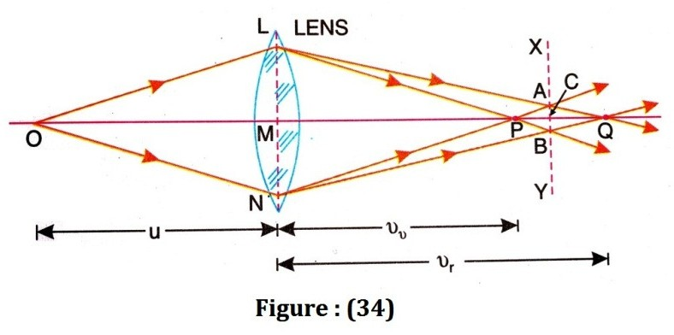

Consider a point object illuminated by white light and situated on the axis of the lens. Coloured images are formed along the axis. The violet image is nearest the lens and the red image is the farthest. In between these two images as shown in given figure (34), if a screen is placed at the position XY, the image of least chromatic aberration is formed.
Let u be the distance of the object and v_{v} and v_{r} the distance of the violet and red images on the axis of the lens. If f_{v} and f_{r} are the focal lengths for the violet and red rays if the light then

1 − 1 = 1
(45)

vv u fv

1 − 1 = 1
(46)

vr u fr
Subtracting eq. (46) from (45)
1 − 1 =

1 − 1

vv vr fv fr

vr − vv =
vvvr
fr − fv

fr fv

Taking, v_{v}v_{r} = v², and ƒ_{v} ƒ_{r} = ƒ²
vr − vv =
v2

fr − fv

f 2

But, ƒ_{r} − ƒ_{v} = ωƒ,
vr − vv = ω f = ω

v2 f 2 f
ωv²

So vr − vv
= (47)
f

It is clearly seen in this case that the longitudinal chromatic aberration depends on the distance of the image and hence on the distance of the object from the lens, in addition to its dependence on the dispersive power and the focal length of the lens.

Eyepieces
• Importance of an objective lens
The magnification power of a simple microscope can be increased by decreasing the focal length of the lens. However, the focal length of a lens cannot be

decreased beyond a certain limit. The lens of a small focal length has a smaller diameter because the curvature of the surface is large and the field of view is small.
Therefore, to increase the magnifying power, two separate lenses are used. The lens near the object is called objective, which forms a real image of an object as shown in figure (35).
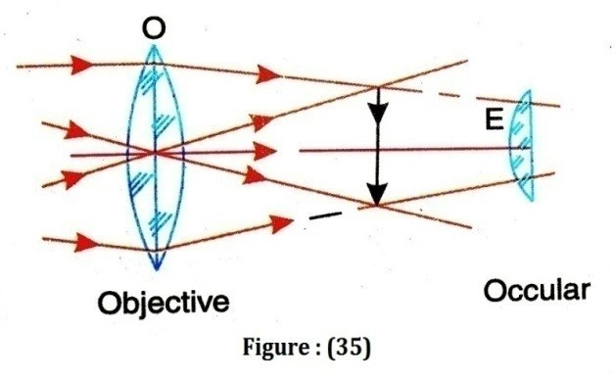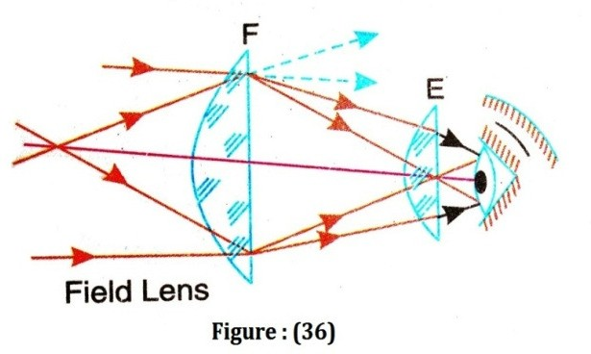

ocular.
The lens used to enlarge this image viewed by the eye, is called eyepiece or

An optical instrument is required to produce a magnified image free from

aberration and a bright image covering a wide field of view. If a single lens is used as an eyepiece, the final image will suffer from spherical and chromatic aberrations.
Another drawback is the small field of view, which becomes lesser and lesser as the magnification of the instrument is increased, The rays passing through the outer portions of the image are refracted through the peripheral portions of the eye lens and they cannot enter the small aperture of the pupil of the eye placed closed to the eye lens see figure (35).
Hence only that part of the image which is nearer to the axis, will be seen.
Therefore, the final image will cover a small field of view.
To increase the field of view and magnifying power an extra lens introduced between objective and eye lens is called a field lens. The function of the field lens is to gather more of the rays from the objective toward the axis of the eye piece see figure (36).
The field lens and the eye lens together constitute an ocular or eyepiece. Two lens are made and kept in such a way that their combination is achromatic and free from spherical aberrations.
There are two types of eyepieces (i) Huygens and (ii) Ramsden eyepiece.

Huygens eyepiece
In the Huygens eyepiece a converging beam enters the field lens and forms a
virtual image before the eye lens.

• Construction
Huygens eyepiece consists of two lenses having focal lengths in the ratio 3:1 and the distance between them is equal to the difference in their focal lengths. The focal lengths and the positions of the two lenses as shown in figure (37). This eyepiece is free from chromatic as well as spherical aberration as it satisfies the two conditions simultaneously.

- 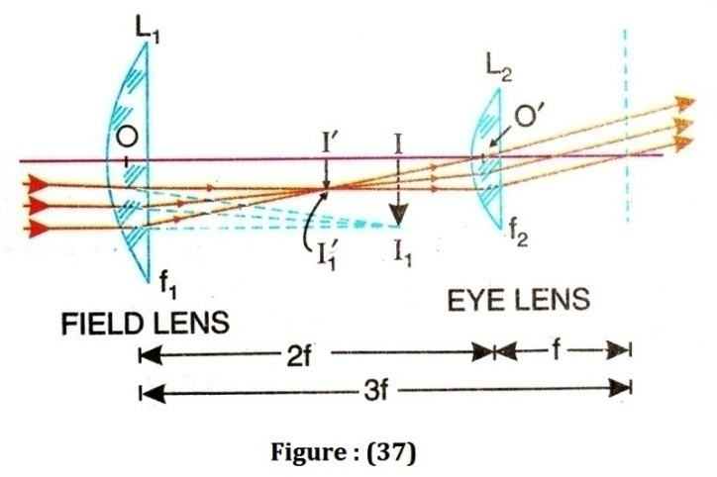The lens combination acts as an achromatic system if

D = f1 + f2
2
, where D is

the distance between the lenses and f₁ and f₂ are the focal length of the two lenses.
- The lenses produces equal deviations of the incident ray when the distance between the two lenses is equal tof₁-f₂
The field and the eye lenses used are plano convex and are placed with their convex surfaces towards the incident ray. In this way, the total deviation due to the combination is divided into four parts which makes the combination to have minimum spherical aberration.
In spherical and chromatic aberrations are to be minimized simultaneously, the following condition is to be satisfied.

D = f1 + f2
2
for Chromatic aberration

D = f1 − f2
Combining the two aberrations, we obtain
for Spherical aberration

f1 + f2 = f − f
2 1 2
f2 = 3 f1

or ∴ D = 3 f1 − f1 = 2 f1
(48)

Thus satisfy the conditions for minimum chromatic and spherical aberrations, the focal length of the field lens should be three times the focal length of the eye lens and the distance between them should be equal to twice the focal length of the eye lens. Huygens’ eyepiece is constructed on this principle.

• Theory
The objective forms an image, which serves as a virtual object for the field lens. The field lens forms real inverse image I’I’₁. If this image is situated at the principal focus of the eye lens, then the final image is at infinity.

• Equivalent focal length:
The equivalent focal length of the eyepiece can be found as follows. If F is the equivalent focal length of the eyepiece, then it is given by
1 = 1 + 1 − d
F f1 f2 f1 f2
1 = 1 + 1 − 2 f = 2

F f
F = 3 f
2
3 f 3 f 2 3 f

(49)

The equivalent lens leis behind field lens at a distance of

2 f × 3 f
x = d × F = 2 = 3 f f f
In other words, the equivalent lens is at a distance of 3 f − 2 f = f
the eye lens.

(50)
behind

• Position of cross wire:
It has been observed that the principal focus of the equivalent lens lies ƒ/2 before the eye lens. The image due to objective must be formed in order that the final image is at infinity. The rays coming from the objective are focus at I₁. It is here that the cross-wire should be placed. The image I I₁ is at a distance of ƒ/2 from the eye lens or 3 ƒ/2 from the field lens. Hence, for field lens u = -3 ƒ/2. Then
1 + 1 = 1
u v f
∴− 2 + 1 = 1
3 f v 3 f
or v = f (51)
In other words, II₁ lies midway between the two lenses and so fixes the position of the cross wire or scale at this position. Since the image found by the objective lies behind the field lens, hence this eyepiece is called a negative eyepiece. It may be noted that the image of the scale is formed by the eye lens where as the final image is produced by both the lenses. Hence the image and the scale would not be magnified equally and so the measurements will not be reliable. The image of the cross wire or scale would have all the defects of an image formed by a single lens. Hence in instruments using Huygens’ eyepieces, scale is not used.

• Merits and Demerits
- Huygens’ eyepiece is fully free from chromatic aberration because the distance between the lenses is equal to half the sum of their focal lengths.
- Spherical aberration is also minimum because the distance between the two lenses is equal to the difference of their focal lengths.
- The field of view of this eyepiece is smaller than that of Ramsden’s eyepiece.

Cardinal points of Huygens eyepiece:
- First principal points:

We have equivalent focal length F =
3ƒ
- , f₂=f and f₁=3f

The equivalent lens should be placed at a distance α from the field lens, which is

given by ∝=
d×F ƒ2
2ƒ×3ƒ
= 2
ƒ
= 3ƒ

Since the distance between the field lens L₁ and the eye lens L₂ is 2f, the position of
equivalent lens is given by 3ƒ − 2ƒ = ƒ
i.e. it should be placed away from the eye lens as shown by dotted line at P1 as shown in figure. The first principal point P₁ lies at a distance ∝= 3ƒ from the field lens.

- Second principal points:
The second principal point P₂ lies at a distance β from the eye lens

towards the field lens and is given by þ = −
d×F ƒ1
–2ƒ×3ƒ
= 2
3ƒ
= −ƒ

Hence, the second principal point P₂ lies before a distance f from the eye lens.

- First focal points:
The first focal point F₁ from lens L₁ is given by
dL F = −F (1 − )
1 1 ƒ2

3
= − 2 ƒ (1 −
3
∴ L₁F₁ = 2 ƒ
2ƒ) ƒ

3

Hence, first focal point F₁ lies at a distance 2 ƒ from the field lens L₁.
- Second focal points:
The second focal point F₂ from lens L₂ is given by
dL F = F (1 − )
2 2 ƒ1
3 2ƒ
= 2 ƒ (1 − 3ƒ)
ƒ
∴ L₂F₂ = 2
ƒ
Hence, second focal point F₂ lies at a distance 2 from the eye lens L₂.
The cardinal points are shown in above figure.

Ramsden eyepiece
Ramsden’s eyepiece consists of two plano convex lenses each of focal length
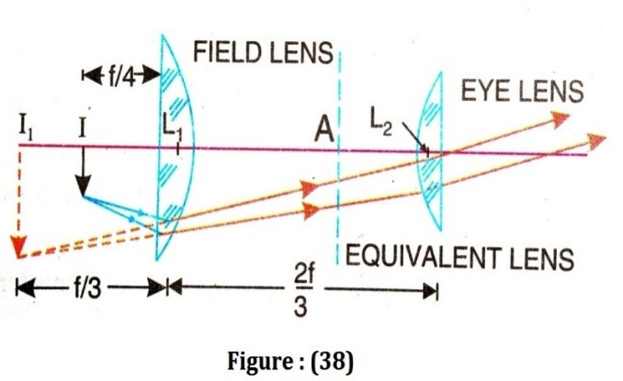ƒ separated by a distance equal to (2/3) ƒ . The lenses are kept with their curved surface facing each other, as shown in the figure (38), thereby reducing spherical aberration. The field lens is a little larger than the intermediate image and is placed close to this image to as much light as possible to pass through it. The eye lens has a smaller diameter but carries out the actual magnification.

• Theory
The objective forms the real inverted image I of object. The field lens gives a virtual image I_{1.} I₁ is the object for the eye lens, which gives the final image at infinity, because I₁ made to lie at its principal focus.

• Equivalent focal length:
The equivalent focal length of the eyepiece can be found as follows. If F denotes the focal length of the equivalent lens, then
1 = 1 + 1 − d
F f1 f2 f1 f2

1 = 1
+ 1
2 f
− 3 = 2

F f f f ² 3 f

= 2 − 2 = 4
f 3 f 3 f
∴ F = 3 f
4

(52)

The equivalent lens of focal length
F = 3 f
4
must be placed behind the field lens at a
3 2

F × d
( ) f × ( ) f
4 3 f

distance
α = = =
f f 2
(53)

Thus the equivalent lens lies between the field lens and the eye lens.

- Position of the cross wire:
The cross wire should be placed at the position of I. Now, the position of I relative to field lens can be found as follows.
If the final image is to be formed at infinity, the image I should lie in the focal plane of the equivalent lens. In other words, the distance AI should be equal to F=(3 ƒ
) / 4. Since AL₁ = ƒ/2, I₄ = ƒ/4. Therefore, the objective should produce the image at a distance of ƒ/4 in front of the field lens. A fine scale may be placed here. Since the scale and image would be magnified equally, the measurement would be true.

- Merits and Demerits:
- The field of view of the eyepiece is fairly wide.
- It is not entirely free from chromatic aberration since the distance between the two lenses is not equal to half the sum of their focal lengths. However, chromatic aberration is minimized by using an achromatic combination both for the field lens and the eye lens.
- Spherical aberration is minimized by using two plano-convex lenses.
Ramsden’s eyepiece is used practically in all instruments where measurements of the size of the final image are to be made. The eyepiece is sometimes referred to as positive eyepiece because a real image is formed by the objective in front of the field lens, which further acts as a real object for the eye lens.

Cardinal points of Ramsden eyepiece:
- First principal points:
3ƒ

We have equivalent focal length F =
4 , d =
2ƒ
- f₂=f and f₁=f

The equivalent lens should be placed at a distance α from the field lens, which is

given by ∝=
d×F ƒ2
2 3ƒ
= 3 4 = ƒ
ƒ×
ƒ 2
2ƒ

Since the distance between the field lens L₁ and the eye lens L₂ is d =
3 , the

3ƒ ƒ ƒ

position of equivalent lens is given by
4 − 2 = 4
ƒ

i.e. it should be placed before the eye lens at a distance 4 as shown by dotted
ƒ
line at P1 as shown in figure. The first principal point P₁ lies at a distance ∝= 2 from the field lens.

- Second principal points:
The second principal point P₂ lies at a distance β from the eye lens

towards the field lens and is given by þ = −
d×F ƒ1
2ƒ×3ƒ
= − 3 4
ƒ
ƒ
= − ^{ƒ}
2

Hence, the second principal point P₂ lies before a distance 2 from the eye
lens.

- First focal points:
The first focal point F₁ from lens L₁ is given by
dL F = −F (1 − )
1 1 ƒ2

3
= − 4
2 ƒ
ƒ (1 − 3 )
ƒ

∴ L F = − ƒ
1 1 4

lens L₁.
ƒ
Hence, first focal point F₁ lies before at a distance − from the field
4

- Second focal points:
The second focal point F₂ from lens L₂ is given by
d L₂F₂ = F (1 − ƒ1)
- 2 ƒ
3
= ƒ (1 − )
- ƒ
ƒ
∴ L₂F₂ = 4
ƒ
Hence, second focal point F₂ lies at a distance 4 from the eye lens L₂.
The cardinal points are shown in above figure.

Comparisons of Ramsden eyepiece and Huygens eyepiece

 | Ramsden eyepiece | Huygens eyepiece
1 | Ramsden eyepiece is positive eyepiece. The image formed by the objective lies in front of field lens. Therefore, cross-wire  can be used. | Huygens eyepiece is negative eyepiece. The image formed by the objective lies in between the two lenses. Therefore, cross-wire  cannot be used.
2 | The condition for minimum spherical aberration is not satisfied. But by spreading the deviations over four surfaces ,  spherical aberration is minimized. | The condition for minimum spherical aberration is satisfied.
3 | It does not satisfy the condition for achromatism but can be made achromatic by using an achromatic doublet as the eye  lens. | It satisfies the condition for achromatism.
4 | It is achromatic for only two chosen colours. | It is achromatic for all colour.
5 | The other types of aberrations are better eliminated. Coma is absent and distortion is 5%  higher. | The other types of aberrations like pincushion distortion are not eliminated.
6 | The eye clearance is 5% higher, | The eye clearance is too small  and less comfortable.

